**The Use of Flash Fill**

The Flash Fill feature is a convenient way to avoid entering a lot of data manually.

Let’s use **Flash Fill** to generate employee email addresses using the names entered in Column A.

1. On cell **B4**, enter [baltore@example.com](mailto:baltore@example.com). Press enter.
2. On cell **B5**, enter [lfox@example.com](mailto:lfox@example.com). Press enter.
3. Select the range **B4:B12**.
4. Got the **Data Tab,** click the Flash Fill button to enter similarly formatted email addresses in the range **B6:B12**.

**Formulas**

With Excel, you can enter functions using one of the four methods:

1. Keyboard
2. Insert Function button in the formula bar
3. The AutoSum button in the Home Tab
4. Formula Tab

The method you choose will depend on your typing skills and whether you can recall the function name and required arguments.

**Entering Formula Using the Keyboard**

|  |  |  |  |
| --- | --- | --- | --- |
| **Arithmetic Operator** | **Meaning** | **Example of Usage** | **Result** |
| **-** | Negation | -78 | Negative 78 |
| **%** | Percentage | = 23% | Multiplies 23 by 0.01 |
| **^** | Exponentiation | = 3^4 | Raises 3 to the fourth power |
| **\*** | Multiplication | = 61.5 *C5 | Multiplies the contents of cell C5 by 61.5 |
| **/** | Division | = H3/H11 | Divides the contents of cell H3 by the contents of cell H11 |
| **+** | Addition | = 11 + 9 | Adds 11 and 9 |
| **-** | Subtraction | = 22- F15 | Subtracts the contents of cell F15 from 22 |

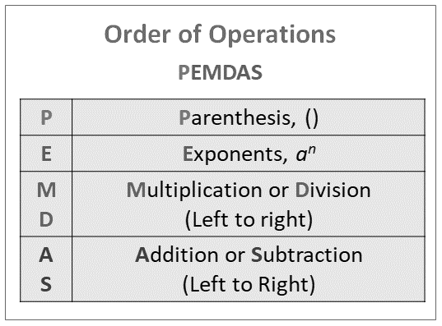

**Gross Pay (column F)** = Hours Worked x Hourly Pay Rate or = **D4** * **E4**

**Federal Tax (column G)** = 0.26 x (Gross Pay – Dependents x 22.16) or = 0.26 * (**F4** − **C4** * 22.16)

**State Tax (column H)** = 0.055 x Gross Pay or = 0.055 * **F4**

**Tax % (column I)** = (Federal Tax + State Tax) / Gross Pay or = (**G4** + **H4**) / **F4**

**Net Pay (column J)** = Gross Pay – (Federal Tax + State Tax) or = **F4** − (**G4** + **H4**)

**Copy Formulas Using the Fill Handle**

1. Select **F4: J4**, point to the fill handle, drag the fill handle down through cell **J12**.

**Using AutoSum, AVERAGE, MAX, MIN, and other statistical functions**

1. Determine the Totals by using the AutoSum button.
   1. Display the **Home Tab**.
   2. Select cell **B13.** Click the AutoSum button to sum the contents of the range **D4:D12** in cell **D13**. (Do this for **Gross Pay, Federal Taxes, State Tax and Net Pay**.)
   3. For **Tax %**, copy the formula of **I12** into **I13**.
2. Determine the highest number in a range of numbers by using the Insert Function Dialog Box.
   1. Select cell **C14**.
   2. Click the Insert Function button in the formula bar to display the Insert Function dialog box.
   3. Click MAX in the Select a function list. You may need to scroll.
   4. Click OK (Insert Function dialog box) to display the Function Arguments dialog box.
   5. Replace the text in the Number1 box with the text, **C4:C12.**
   6. Click OK (Function Arguments dialog box) to display the highest value in the chosen range in cell **C14**.
3. Determine the lowest number in a range of numbers by using the Sum Menu.
   1. Select cell C15 and then click the AutoSum arrow (**Home Tab | Editing Group)** to display AutoSum menu.
   2. Click Min to display the **MIN** function in the formula bar and in the active cell.
   3. Click cell **C4** and then drag through cell **C12** to update the function with the new range.
   4. Click the Enter button to determine the lowest value in the range **C4:C12** and display the result in cell **C15**.
4. Determine the average of a range of number by using the keyboard.
   1. Select the cell to contain the average, cell **C16** in this case.
   2. Type **=av** in the cell to display the Formula AutoComplete list. Press the down arrow key to highlight the **AVERAGE** function.
   3. Double-click **AVERAGE** in the Formula AutoComplete list to select the function.
   4. Select the range to be averaged, **C4:C12** in this case, to insert the range as the argument to the function.
   5. Press enter.
5. Copy the formulas used in **C13:C16** to the adjacent cells through cell **J16**. Select **I16** and press delete. Averaging this type of percentage is mathematically invalid.

**Conditional Formatting**

Conditional Formatting is special formatting – the font, font color, background fill, and other options – that is applied if cell values meet specified criteria. Excel offers a variety of commonly used conditional formatting rules, along with the ability to create your own custom rules and formatting.

1. Select the range **D4:D:12**.
2. Click the Conditional Formatting button (**Home tab | Styles group**) to display the Conditional Formatting menu.
3. Click New Rule on the Conditional Formatting menu to display the New Formatting Rule dialog box.
4. Click ‘Format only cells that contain’ in the Select a Rule Type area.
5. In the Edit the Rule Description area, click the arrow in the relational operator box (second box) to display a list of relational operators, and then select greater than to select the desired operator.
6. Click in the rightmost box, and then type **70** to enter the value of the rule description.
7. Click the Format button (New Formatting Rule dialog box) to display the Format Cells dialog box.
8. Change the font color to while and the fill to purple.

**Manola Department Store Example**

**IF Function**

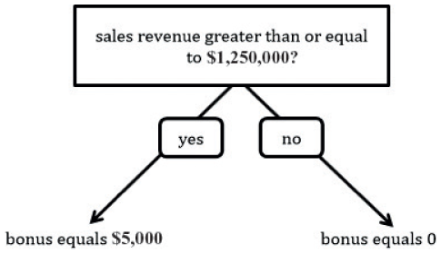

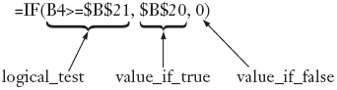

IF functions can use logical operators, such as AND, OR, and NOT. For example, the three IF functions =IF(AND(A1>C1, B1<C2), “OK”, “Not OK”) and =IF(OR(K5>J5, C3<K6), “OK”, “Not OK”) and =IF(NOT(B10<C10), “OK”, “Not OK”) use logical operators.

1. Click cell **B9** to select the cell for the next formula.
2. Click the Insert Function button in the formula bar to display the Insert Function dialog box.
3. Click the ‘Or select a category’ arrow (Insert Function dialog box) and then select Logical in the list to populate the ‘Select a function’ list with logic functions.
4. Click IF in the ‘Select a function’ list to select the required function.
5. Click OK (Insert Function dialog box) to display the Function Arguments dialog box.
6. Type **B4>=B21** in the Logical_test box to enter a logical test for the IF function.
7. Type **B20** in the Value_if_true box to enter the result of the IF function if the logical test is true.
8. Type 0 (zero) in the Value_if_false box to enter the result of the IF function if the logical test is false.

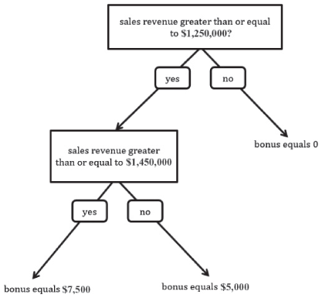

**Adding and Formatting Sparkline Charts**

Sometimes you may want to condense a range of data into a small chart in order to show a trend or variation in the range, and Excel’s standard charts may be too large or extensive for your needs. A sparkline chart provides a simple way to show trends and variations in a range of data within a single cell. Excel includes three types of sparkline charts: line, column, and win/loss.

1. Select cell **I4** to prepare to insert a sparkline chart in the cell.
2. Display the Insert tab and then click the Line button (**Insert tab | Sparklines group**) to display the Create Sparklines dialog box.
3. Select B4:G4.

**Adding and Customizing Charts**

1. Select the range A3:G3 to identify the range of the categories.
2. Hold down ctrl and select the data range A9:G13.
3. Display the Insert tab.
4. Click the Recommended Charts button (Insert tab | Charts group) to display the Insert Chart dialog box with the Recommended Charts tab active.
5. Click the first Clustered Column recommended chart to select it and then click OK (Insert Chart dialog box).
6. After Excel draws the chart, click the Move Chart button (Chart Tools Design tab | Location group) to display the Move Chart dialog box.
7. Click the New sheet option button (Move Chart dialog box) and then type Expense Chart Sheet in the New sheet text box to enter a sheet tab name for the chart sheet.
8. Click OK.