Excel Intro to PivotTable

Class Outline

# Definition

A PivotTable is an interactive tool that summarizes worksheet data. It uses filter buttons in the cells and a pane to change the way the data is presented without changing any of the original data. PivotTables allow you to view different summaries of the data quickly and easily, using just a single table.

PivotTables use two types of fields: data fields, which contain values that the PivotTable will summarize, and category fields, which describe the data by categorizing it.

# To Create a Blank PivotTable

1. Click the Analysis Figures sheet tab to make the worksheet active.
2. Click cell B3 to select a cell containing data for the PivotTable.
3. Display Insert Tab.

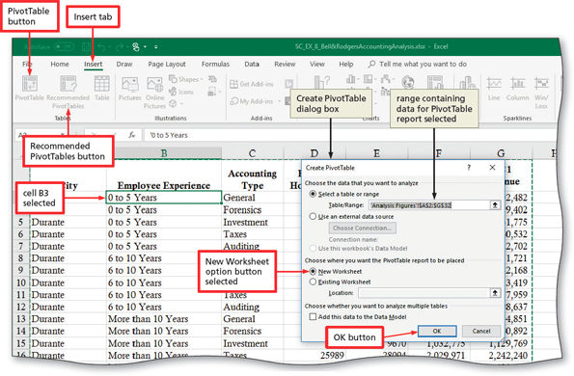

1. Click OK (Create PivotTable dialog box) to create a blank PivotTable report on a new worksheet and display the Field List. 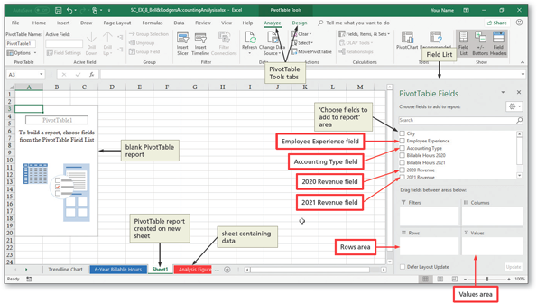

## Other Ways

Click cell in range, click Recommended PivotTables (Insert Tab | Tables group), click Blank PivotTable button (Recommended PivotTables dialog box), click OK.

# To Add Data to the PivotTable

Once the blank PivotTable is created, it needs to be populated using any or all of the fields in the Field List. You can add data by selecting check boxes in the Field List or by dragging fields from the Choose fields area to the one of our four boxed areas in the lower part of the pane. Once you add a field, it becomes a button in the pane, with its own button menu.

|  |  |
| --- | --- |
| **Field Areas in the PivotTable Fields Pane** | |
| **Areas** | **Use** |
| **Filters** | Fields added to the Filters area create a report filter and filter button in the PivotTable, representing a subset that meets a selection criterion. |
| **Columns** | Normally, Excel creates a field in the Columns area when multiple fields are dragged to the Values area. Fields directly added to the Columns fields should contain summary numeric data. |
| **Rows** | Fields added to the Rows area become rows in the PivotTable. Subsequent fields added to the Rows area become subsets of the first field. |
| **Values** | Fields added to the Values area must contain numeric data from the source data. |

The following steps adds data to the PivotTable. The rows will show the accounting type and, within that, the years of employee experience. As you add the 2020 Total Revenue and 2021 Total Revenue fields to the values area, Excel will create columns.

1. Drag the **Accounting Type** field from the ‘Choose fields to add to report’ are the Rows area to add the field to a row in the PivotTable.
2. Click the **Employee Experience** check box in the ‘Choose fields to add to report’ area to add the Employee Experience field to the Rows area below the Accounting Type field.
3. Drag the **2020 Revenue** field to the Values area to add the field to column B of the PivotTable.
4. Drag the **2021 Revenue** field to the Values area to add the field to column C of the PivotTable.

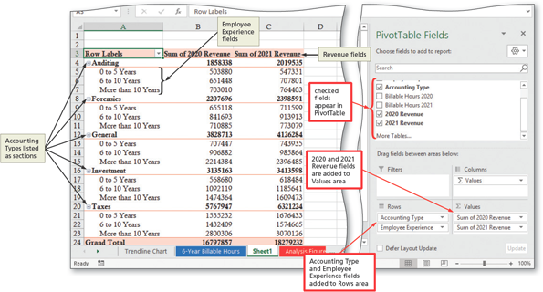

## Other Ways

Click check box for each field name (Field List).

# To Change the Layout of a PivotTable

You can display a PivotTable in one of three layouts. By default, PivotTable reports are presented in a compact layout. The following steps change the layout of the PivotTable report to the tabular layout and then add item labels to all row.

1. If necessary, display the PivotTable Tools Design tab.
2. Click the Repost Layout button (PivotTable Tools Design tab | Layout group) to display the Report Layout menu.

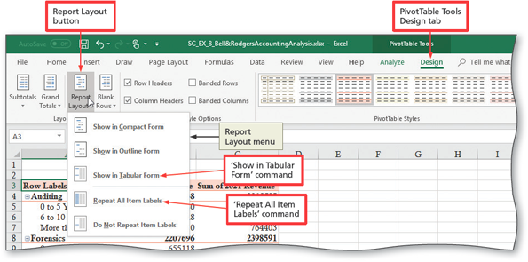

1. Click ‘Show in Tabular Form’ to display the PivotTable
2. Click the Report Layout button (pivotable Tools Design tab | Layout group) again, and then click ‘Repeat All Items Labels’ to display Accounting Type label for all Employee Experience entries.

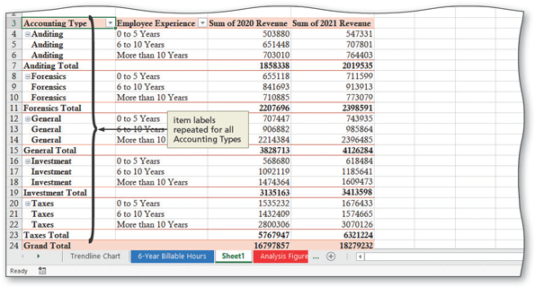

# To Change the View of a PivotTable Report

1. In the Rows area (Field List), drag the **Accounting Type** button below the **Employee Experience** button to group total sales by **Employee Experience** (rather than Accounting Type).

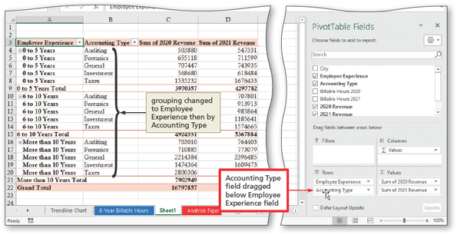

# To Filter a PivotTable Report Using a Report Filter

1. Drag the **City** field from the ‘Choose fields to add to report’ area (Field List) to the Filters area to create a report filter in the PivotTable.

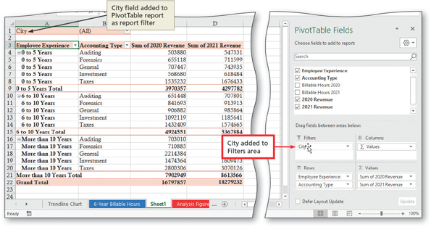

1. Click the filter button in cell B1 to display the filter menu for column B, City in this case.
2. Click Durante on the filter menu to select the Durante criterion.

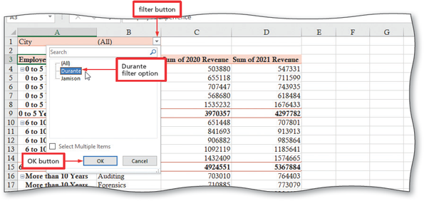

1. Click OK to display totals for Durante only.

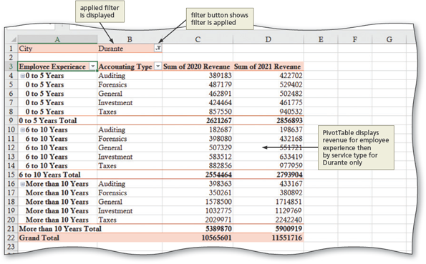

# To Filter a PivotTable Report Using Multiple Selection Criteria

1. Drag the **Accounting Type** button from the Rows area to the Filters area.
2. Drag the **city** button from the Filters area to the Rows area below **Employee Experience**.

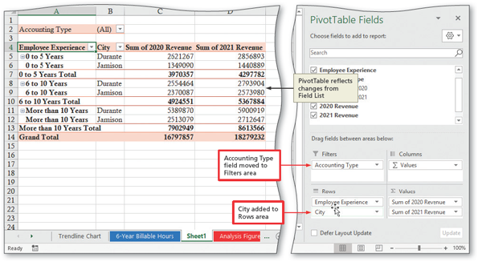

1. Click the filter button in cell B2 to display the filter menu for the **Accounting Type** field.
2. Click the ‘Select Multiple Items’ check box to prepare to select multiple criteria.
3. Click to remove the check mark in each of the Auditing, Forensics, and Investment check boxes to deselect these criteria and leave only the General and Takes services plans selected.

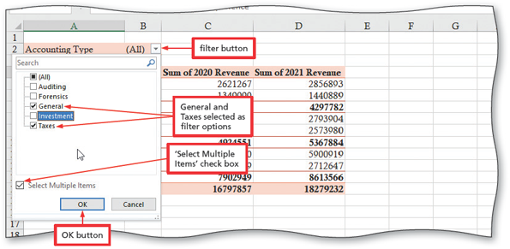

1. Click OK to display revenue totals for General and Taxes accounting types in the cities of Durante and Jamison.

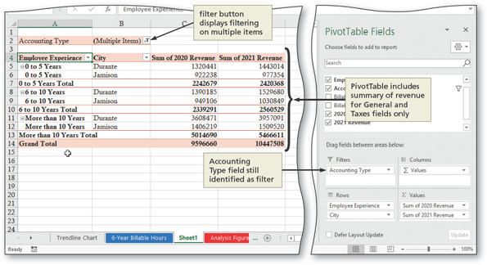

# To Remove a Report Filter from a PivotTable Report

1. Click the filter button in cell B2 and then click the (All) check box to include all service type criteria in the PivotTable report.
2. Click OK.
3. Drag the Accounting Type button out of the Filters area (Field List) to remove the field from the PivotTable report.

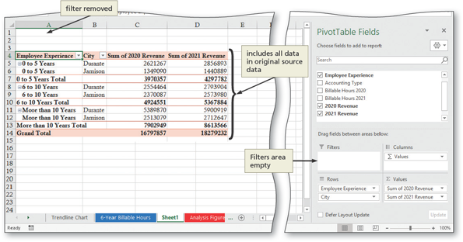

# To Remove and Add Data to the PivotTable Report

1. In the Field List, drag the city button out of the Rows area to remove the field from the report.
2. Click the Accounting Type check box in the ‘Choose fields to add to report’ area to add the Accounting Type field to the Rows area below the Employee Experience field.

# To Filter a PivotTable Report Using the Row Label Filter

1. Click the filter button in cell B4 to display the filter menu for the Accounting Type field.
2. Click the Auditing, Forensics, and Investments check boxes on the filter menu to leave only the General and Taxes service plans selected.

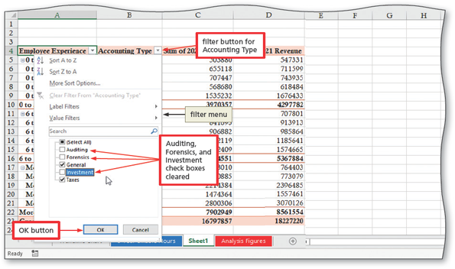

1. Click OK to display totals for General and Taxes only, categorized by experience.

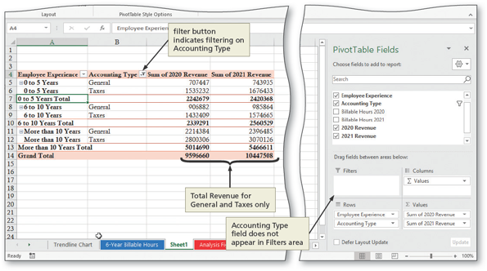

# To Clear the Filter

1. Click the filter button in cell B4 again to display the filter menu for the Accounting Type field.

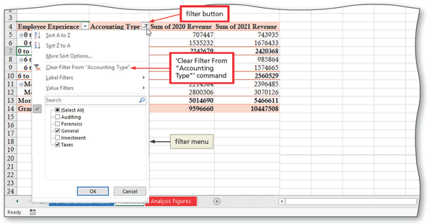

1. Click ‘Clear Filter From “Accounting Type” on the filter menu to display totals for all service types in all regions.

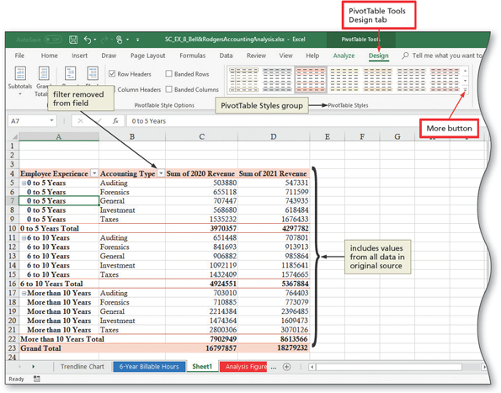

# To Format a PivotTable Report

1. Name the Sheet1 tab, Revenue PivotTable, and se the color to Tan, Accent 2.
2. Click cell A7 to select a cell in the PivotTable.
3. Click the More button in the PivotTable Styles group (PivotTable Tools Design tab | PivotTable Styles group) to expand the gallery.
4. Scroll down until the Dark section of the gallery is visible.
5. Point to ‘Dark Gray, Pivot Style Dark 9’ (PivotTable Styles gallery) to display a preview of the style in the PivotTable.

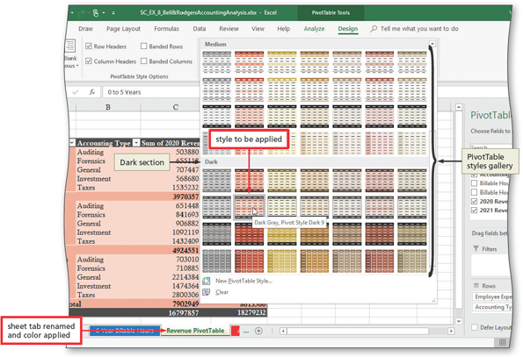

1. Right-click cell C6 and then Number Format on the shortcut menu to display the Format Cell dialog box.
2. Click Currency in the Category list (Format Cell dialog box) to select the Currency number format.
3. Type 0 in the Decimal places box to specify no decimal places.

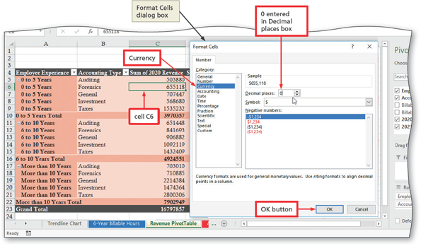

1. Click OK to apply the Currency style with no decimal places to all 2020 revenue value in the PivotTable report.
2. Right-click cell D6 and then the Currency number format with zero decimal places to all 2021 revenue value.
3. Click cell E24 to deselect the PivotTable report.
4. Click the Save button on the Quick Access Toolbar to save the workbook.

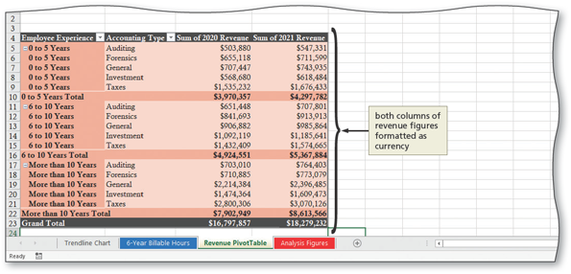

# To Switch Summary Functions

1. Right-click cell C5 to display the shortcut menu and then point to ‘Summarize Values By’ to display the Summarize Values By submenu.

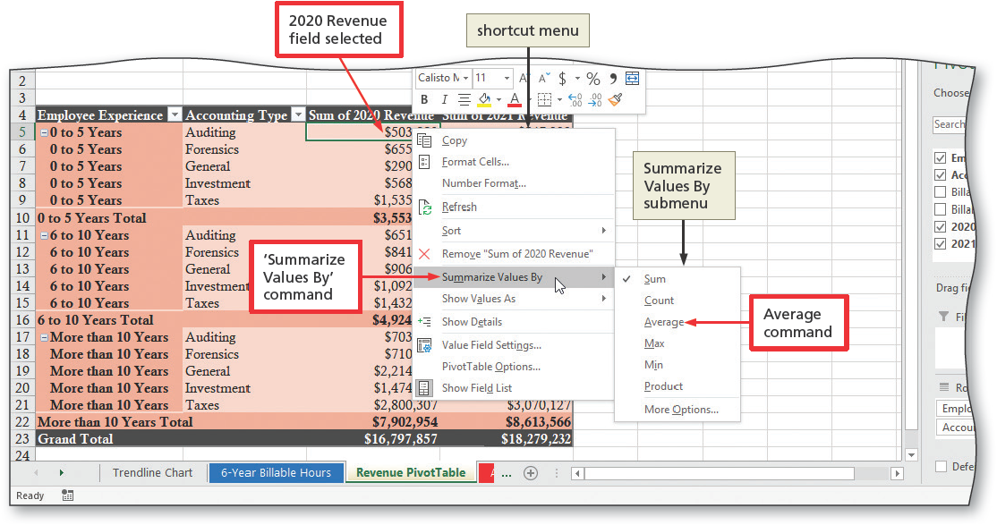

1. Click Average on the Summarize Values By submenu to change the Summary function from Sum to Average.

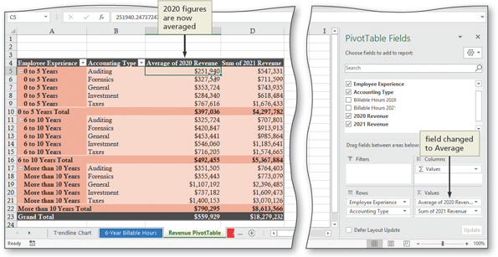

1. Repeat Steps1 and 2 to change the summary function used in column D from Sum to Average.